CREATE TABLE students_info (

stud_id INT AUTO_INCREMENT PRIMARY KEY,

stud_name VARCHAR(100),

class VARCHAR(50),

division VARCHAR(10),

city VARCHAR(100)

);

INSERT INTO students_info (stud_name, class, division, city) VALUES

('John Doe', '10', 'A', 'New York'),

('Jane Smith', '10', 'B', 'Los Angeles'),

('Alice Johnson', '9', 'A', 'Chicago');

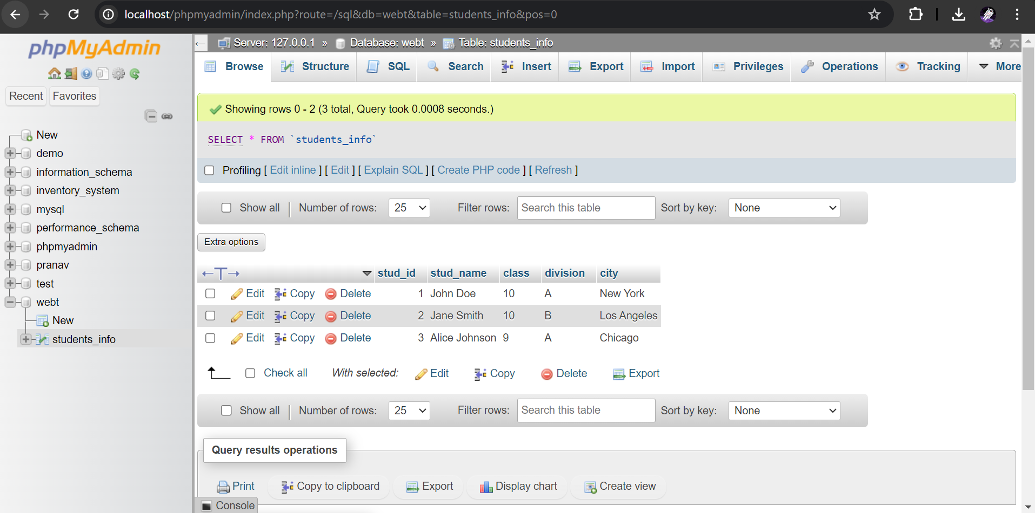

<%@ page import="java.sql.*" %>

<%@ page contentType="text/html;charset=UTF-8" language="java" %>

<html>

<head>

<title>Students Info</title>

</head>

<body>

<h1>Students List</h1>

<table border="1">

<tr>

<th>Student ID</th>

<th>Name</th>

<th>Class</th>

<th>Division</th>

<th>City</th>

</tr>

<%

Connection conn = null;

Statement stmt = null;

ResultSet rs = null;

try {

Class.forName("com.mysql.cj.jdbc.Driver");

conn = DriverManager.getConnection("jdbc:mysql://localhost:3306/your_database_name", "your_username", "your_password");

stmt = conn.createStatement();

String sql = "SELECT * FROM students_info";

rs = stmt.executeQuery(sql);

while(rs.next()) {

out.println("<tr>");

out.println("<td>" + rs.getInt("stud_id") + "</td>");

out.println("<td>" + rs.getString("stud_name") + "</td>");

out.println("<td>" + rs.getString("class") + "</td>");

out.println("<td>" + rs.getString("division") + "</td>");

out.println("<td>" + rs.getString("city") + "</td>");

out.println("</tr>");

}

} catch(Exception e) {

e.printStackTrace();

} finally {

try { rs.close(); } catch(Exception e) { }

try { stmt.close(); } catch(Exception e) { }

try { conn.close(); } catch(Exception e) { }

}

%>

</table>

</body>

</html>

